**Part 1**

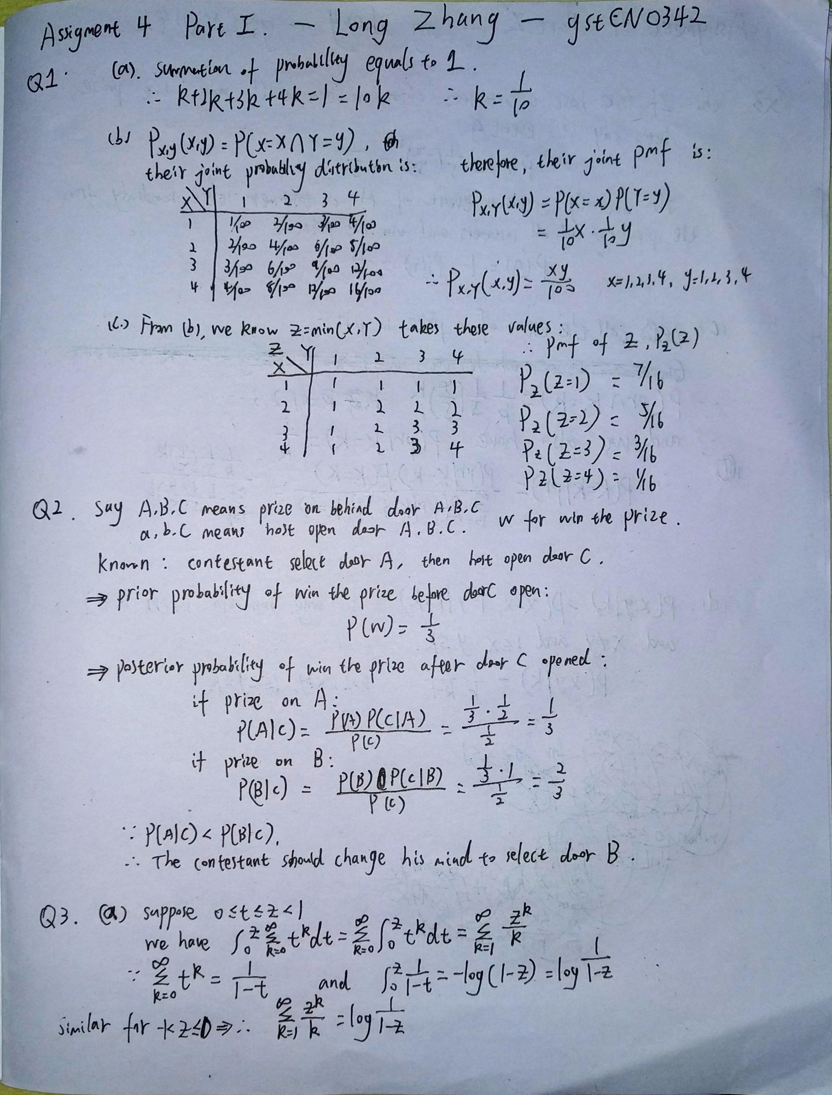

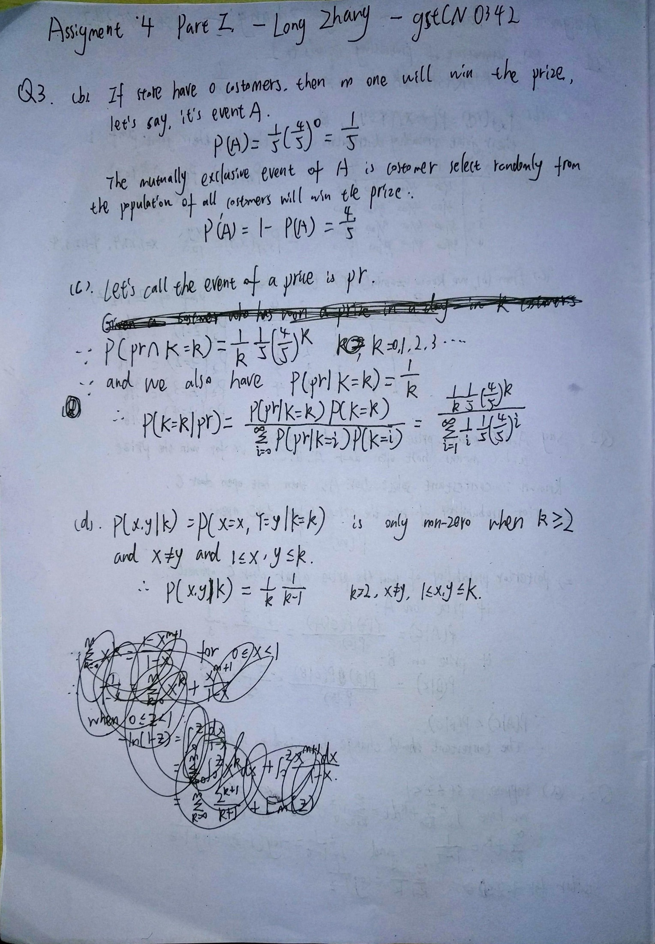

**Part 2**

**Q4. The pose of the head can affect the performance of a face detector. Apply the face detection function on test1.png, test2.png and test3.png, and compare the results.**

For test1.png, algorithm didn’t recognize the face in this picture. It’s a complete side face. Easy for human, seems hard for computers.

For test2.png, face turned outside a little, but algorithm recognized a wrong position.

For test3.png, algorithm successfully recognized the face, the front face, most clearly.

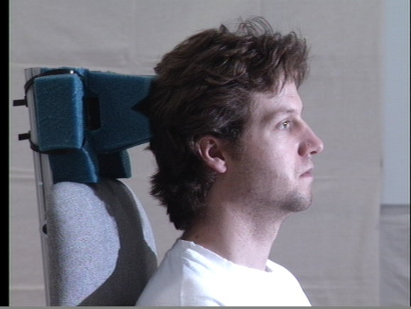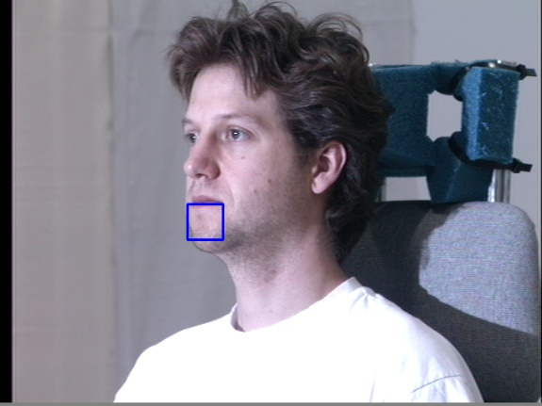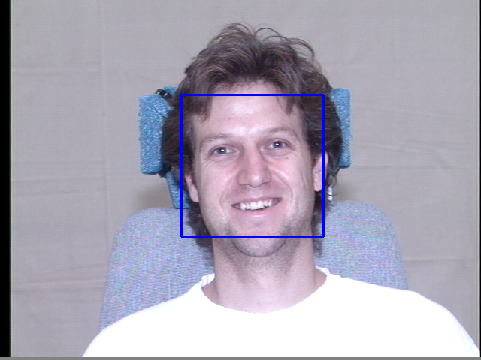

**Q5. What other factors do you think can affect the performance of the face detector? Confirm your answers by using your own images, and showing the success or failure of the detector on your images. (At least two other factors).**

The light will affect. (use my photos below to test)

Seems algorithm perform well in dark environment, but worse in highlight environment.

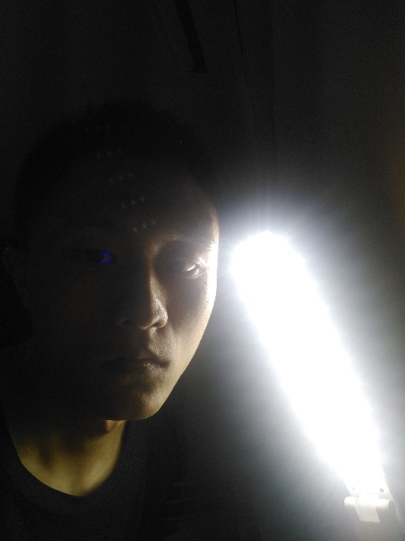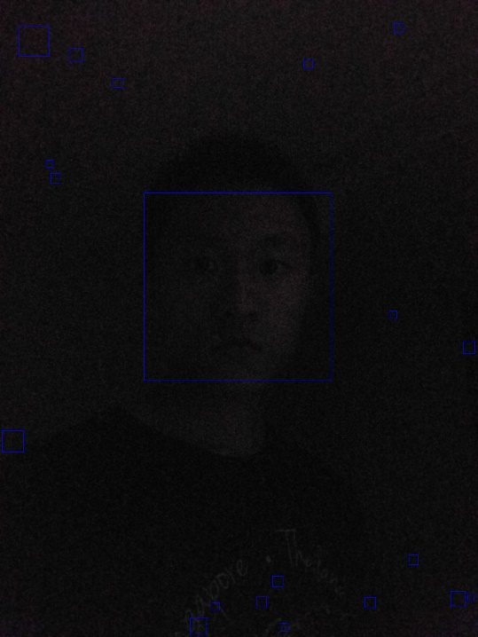

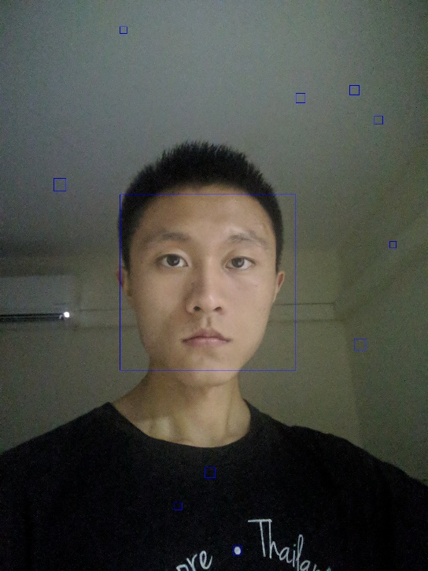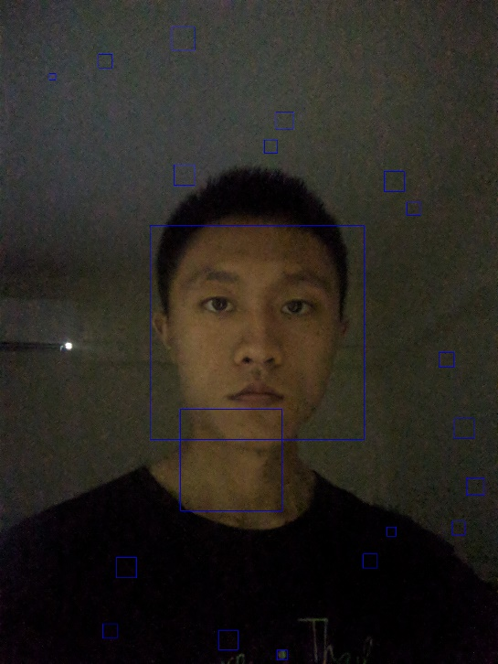

Although, there are noisy in dark room, but algorithm still recognize the most important part--face

The other thing that will affect face reorganization are wearing objects, ornaments, etc. These objects that will block the facial features.

Like my picture below, when I wear sunglasses and a hat, wow, it didn’t recognize it is me!

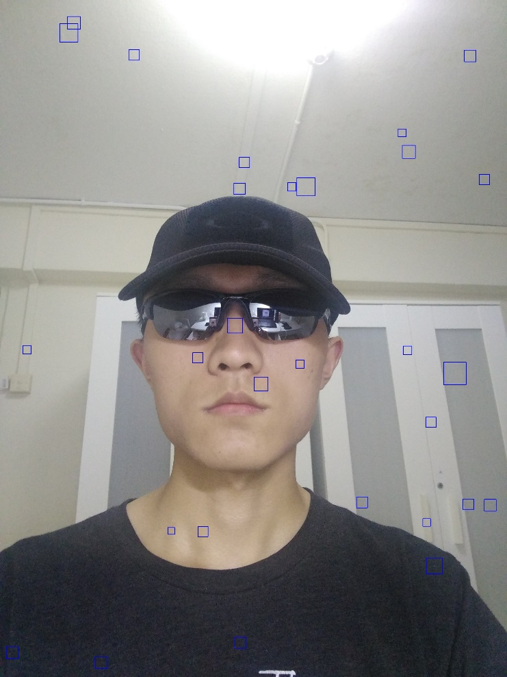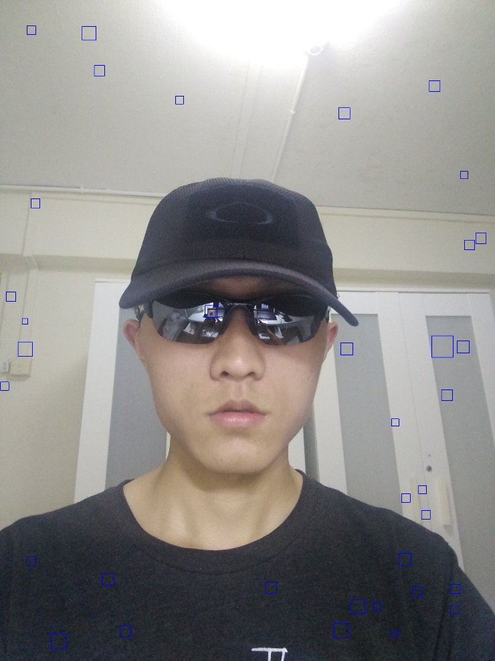

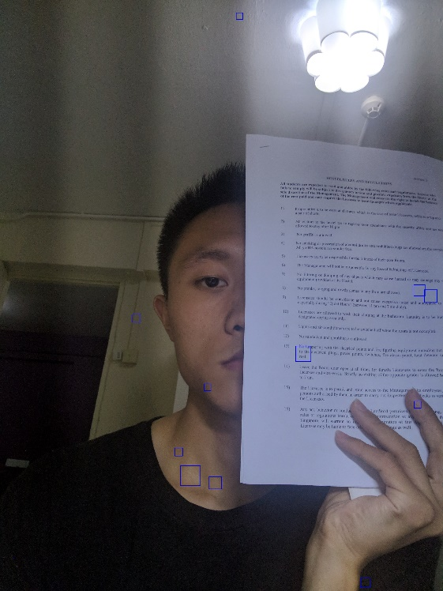

For the others(untested), I think people’s emotion on their face will also matters.

**Part 3**

